# Industrial Internship Report on

# Smart city

**Forecasting of Smart city traffic patterns**

**”**

# Prepared by: Nupur Luhar

|  |
| --- |
| *Executive Summary* |
| This report provides details of the Industrial Internship provided by upskill Campus and The IoT Academy in collaboration with Industrial Partner UniConverge Technologies Pvt Ltd (UCT).  This internship was focused on a project/problem statement provided by UCT. We had to finish the project including the report in 6 weeks’ time.  My project was **Forecasting of Smart city traffic patterns**  **”**  This internship gave me a very good opportunity to get exposure to Industrial problems and design/implement solution for that. It was an overall great experience to have this internship. |

**TABLE OF CONTENTS**

1. Preface 3
2. Introduction 5
   1. About UniConverge Technologies Pvt Ltd 5
   2. About upskill Campus 8
3. Problem Statement 10
4. Existing and Proposed solution 111
5. Proposed Design/ Model
   1. High Level Diagram 16
   2. Low Level Diagram 17
   3. Interface 17
6. Performance Test 20
   1. Test Plan/ Test Cases 21
   2. Test Procedure 23
   3. Performance Outcome 25
7. My learnings 27
8. Future work scope 28
9. Conclusion 29

### Preface

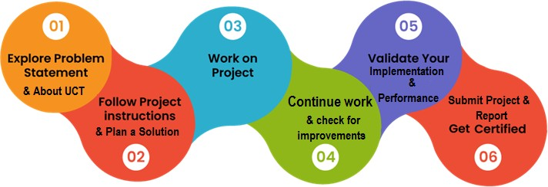

* + The 6-week internship program in the Internet of Things (IoT) offered participants an immersive and comprehensive experience in the field of IoT. Throughout the program, interns had the opportunity to dive deep into various aspects of IoT, gaining hands-on experience, collaborating on projects, and learning from industry experts.
  + The internship program began with a thorough introduction to IoT, covering its core principles, architecture, and the interconnected nature of devices and systems. Interns learned about different IoT components, including sensors, actuators, gateways, and communication protocols. They gained a solid understanding of how these components work together to enable data collection, analysis, and automation.
  + As the program progressed, interns engaged in practical exercises and projects to apply their knowledge in real-world scenarios. They worked on assembling IoT devices, connecting them to cloud platforms, and developing applications to monitor and control these devices remotely. Through these hands-on activities, interns honed their skills in hardware setup, programming, and data integration.
  + A significant focus of the internship program was on data analytics and visualization in the context of IoT. Interns learned how to collect, process, and analyze data generated by IoT devices. They explored various techniques and tools for data interpretation and visualization, gaining insights into extracting meaningful information from vast amounts of IoT-generated data.
  + Collaboration and teamwork were integral to the internship program. Interns worked in groups on IoT projects, brainstorming ideas, designing prototypes, and solving problems collectively. This fostered a collaborative environment and allowed interns to learn from each other's expertise and perspectives, mirroring real-world IoT project dynamics.
* Throughout the program, interns had the opportunity to interact with industry professionals and experts in IoT. They attended workshops, seminars, and guest lectures, where they gained insights into emerging trends, industry applications, and best practices in IoT. These interactions provided valuable networking opportunities and allowed interns to broaden their professional connections.
* The internship program also emphasized the ethical and security considerations of IoT. Interns learned about data privacy, cybersecurity threats, and the importance of building secure IoT systems. They explored strategies for mitigating risks and ensuring the integrity, confidentiality, and availability of IoT data and infrastructure.
* At the culmination of the internship program, interns presented their projects and shared their experiences with their peers, mentors, and industry professionals. They showcased their practical skills, problem-solving abilities, and innovative ideas in implementing IoT solutions.
* In summary, the 6-week internship program in IoT provided interns with a comprehensive and immersive experience in the field. Through hands-on projects, collaboration, industry interactions, and practical exercises, interns developed a solid foundation in IoT concepts, technologies, and applications. The program equipped interns with the necessary skills and knowledge to pursue careers in IoT, emphasizing critical thinking, problem-solving, and teamwork in the context of real-world IoT implementations.

### Introduction

#### About UniConverge Technologies Pvt Ltd

A company established in 2013 and working in Digital Transformation domain and providing Industrial solutions with prime focus on sustainability and RoI.

For developing its products and solutions it is leveraging various **Cutting Edge Technologies e.g. Internet of Things (IoT), Cyber Security, Cloud computing (AWS, Azure), Machine Learning, Communication Technologies (4G/5G/LoRaWAN), Java Full Stack, Python, Front end** etc.



# UCT IoT Platform ( )

**UCT Insight** is an IOT platform designed for quick deployment of IOT applications on the same time

providing valuable “insight” for your process/business. It has been built in Java for backend and ReactJS for Front end. It has support for MySQL and various NoSql Databases.

* + - * It enables device connectivity via industry standard IoT protocols - MQTT, CoAP, HTTP, Modbus TCP, OPC UA
      * It supports both cloud and on-premises deployments.

It has features to

* Build Your own dashboard
* Analytics and Reporting
* Alert and Notification
* Integration with third party application(Power BI, SAP, ERP)
* Rule Engine

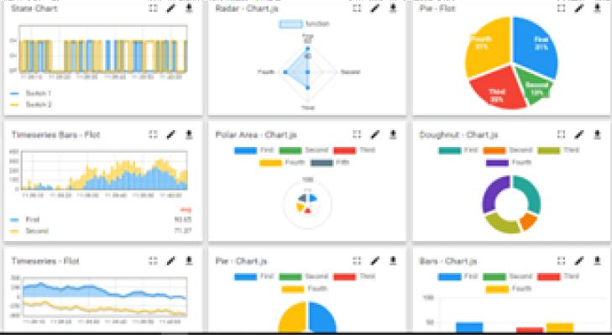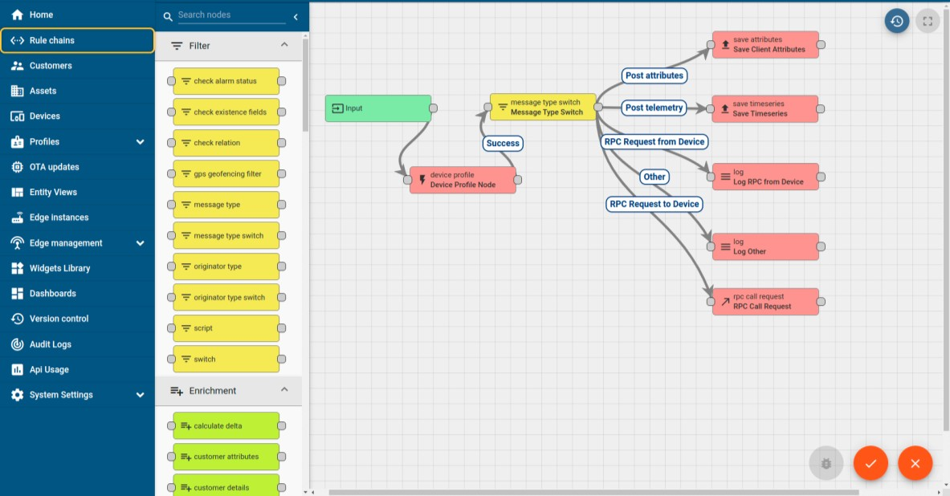

* + 1. **Forecasting of Smart city traffic patterns**
* As cities around the world continue to grow and urbanize, the need for efficient transportation systems becomes increasingly crucial. The concept of a smart city, empowered by advanced technologies and data-driven solutions, offers a promising approach to tackle the challenges of urban mobility. One key aspect of smart cities is the ability to forecast and manage traffic patterns effectively.
* Forecasting smart city traffic patterns involves using various data sources, such as sensors, cameras, GPS, and mobile devices, to gather real-time information about traffic flow, congestion, and other relevant factors. This data is then processed and analyzed using advanced algorithms and machine-learning techniques to generate accurate predictions and insights into future traffic patterns.
* By forecasting traffic patterns, smart cities can proactively plan and optimize transportation systems, improve road safety, reduce congestion, and enhance overall mobility for residents and visitors. It enables city authorities to make informed decisions regarding traffic management strategies, infrastructure development, and public transportation services.

## What is LoRaWAN? - Yeastar Workplace Help based Solution

UCT is one of the early adopters of LoRAWAN technology and providing solution in Agritech, Smart cities, Industrial Monitoring, Smart Street Light, Smart Water/ Gas/ Electricity metering solutions etc.

## Predictive Maintenance

UCT is providing Industrial Machine health monitoring and Predictive maintenance solution leveraging Embedded system, Industrial IoT and Machine Learning Technologies by finding Remaining useful life time of various Machines used in production process.

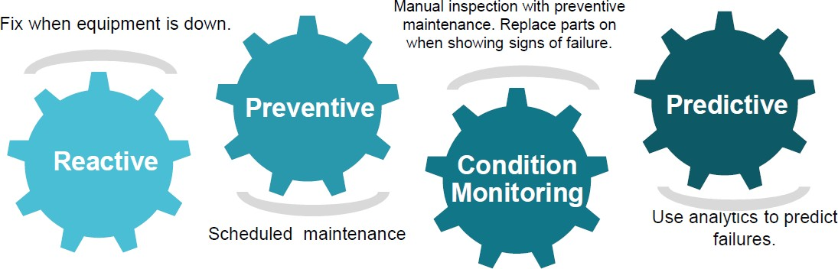

#### About upskill Campus (USC)

upskill Campus along with The IoT Academy and in association with Uniconverge technologies has facilitated the smooth execution of the complete internship process.

USC is a career development platform that delivers **personalized executive coaching** in a more affordable, scalable and measurable way.



Industrial Internship Report

Page 8

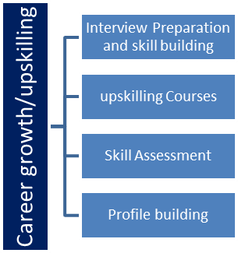  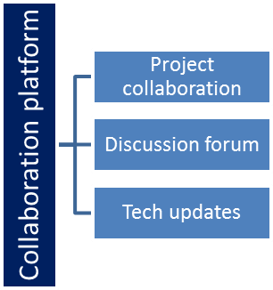

#### The IoT Academy

The IoT academy is EdTech Division of UCT that is running long executive certification programs in collaboration with EICT Academy, IITK, IITR and IITG in multiple domains.

#### Objectives of this Internship program

The objective for this internship program was to

* get practical experience of working in the industry.
* to solve real world problems.
* to have improved job prospects.
* to have Improved understanding of our field and its applications.
* to have Personal growth like better communication and problem solving.

### Problem Statement

* Smart cities generate vast amounts of heterogeneous data from various sources such as sensors, cameras, GPS devices, and mobile applications. Managing and integrating this diverse data in real-time can be complex and requires robust data infrastructure and processing capabilities.
* The accuracy and reliability of data collected from different sources can vary, leading to potential inaccuracies in traffic pattern forecasting. Ensuring data quality and addressing issues such as missing or inconsistent data is essential to improve the reliability of traffic predictions.

### Existing and Proposed solution

* + 1. **Existing Solution for Forecasting of Smart city traffic patterns:**
* Existing solutions for forecasting smart city traffic patterns employ a combination of data analytics, machine learning, and advanced technologies.
* Various data-driven modeling techniques, such as time series analysis, regression analysis, and clustering algorithms, are used to analyze historical traffic data and identify patterns and trends. These models are then used to forecast future traffic patterns based on historical data
* Machine learning algorithms, including neural networks, support vector machines, random forests, and deep learning techniques, are employed to learn from historical traffic data and make predictions about future traffic patterns. These algorithms can handle complex patterns and adapt to changing conditions.

### Limitations of Existing Solution for IoT-Based Smart Public Distribution System:

* While existing solutions for forecasting smart city traffic patterns have made significant progress, there are still some limitations that need to be addressed. These limitations include:
* **Data Quality and Reliability:** The accuracy and reliability of data collected from various sources can impact the quality of traffic forecasts. Issues such as missing or inconsistent data, data biases, and sensor failures can lead to inaccuracies in predictions. Ensuring data quality and addressing data reliability issues remain a challenge.
* **Scalability:** As the volume of data generated by smart city systems continues to increase, scalability becomes a crucial limitation. Developing forecasting models that can handle large datasets in real-time without sacrificing performance is a challenge that needs to be overcome.
* **Limited Contextual Information:** While existing solutions consider historical traffic data, incorporating additional contextual information such as weather conditions, road construction, and special events can improve the accuracy of traffic forecasts. However, integrating and updating this dynamic contextual information in real-time poses a challenge.
* **Dynamic and Unpredictable Factors:** Traffic patterns can be influenced by unpredictable factors such as accidents, emergencies, and sudden changes in road conditions. Existing solutions struggle to effectively capture and respond to these dynamic factors, leading to limited accuracy in predicting real-time traffic patterns.
* **Privacy and Security Concerns:** The collection and use of personal data for traffic forecasting raise privacy concerns. Ensuring data privacy and security while still obtaining the necessary data for accurate predictions remains a challenge that needs to be addressed to gain public trust and acceptance.
* **Integration and Collaboration:** Forecasting smart city traffic patterns often requires collaboration among multiple stakeholders, including city authorities, transportation agencies, technology providers, and citizens. Ensuring effective integration and cooperation among these stakeholders can be challenging, leading to fragmented data sources and limited information sharing.
* **Communication and User Accessibility:** Communicating traffic forecasts to the public in a clear and accessible manner is crucial. Existing solutions may lack user-friendly interfaces and decision-support tools, making it challenging for the public to interpret and utilize the forecasted information effectively.
* **Implementation Costs:** Developing and deploying advanced technologies and infrastructure for traffic forecasting in smart cities can be costly. Limited financial resources may hinder the widespread adoption and implementation of sophisticated forecasting solutions, especially in resource-constrained cities.
* **Limited Adaptability:** Existing forecasting models may have limitations in adapting to rapidly changing traffic conditions and emerging trends. The ability to adapt to evolving urban environments, new transportation modes, and emerging technologies is crucial for accurate and reliable traffic forecasting.
* **Value addition for Forecasting of Smart city traffic patterns:**
* Value addition for forecasting smart city traffic patterns can be achieved through several enhancements and improvements. These value additions include:
* **Real-time Updates:** Enhancing the forecasting systems to provide real-time updates on traffic patterns can significantly improve their value. By integrating real-time data from sensors, cameras, and mobile devices, cities can provide up-to-the-minute information to drivers, commuters, and city authorities, enabling them to make informed decisions and adapt their routes or transportation modes accordingly.
* **Integration of Multiple Data Sources:** Incorporating a wide range of data sources beyond traditional traffic data, such as weather data, social media data, and event data, can enhance the accuracy and contextuality of traffic forecasts. By integrating these diverse datasets, cities can gain a more comprehensive understanding of traffic patterns and provide more precise predictions.
* **Predictive Analytics:** Going beyond simple traffic pattern forecasting, advanced predictive analytics can provide insights into future traffic scenarios and trends. By leveraging historical data, machine learning algorithms, and predictive modeling techniques, cities can anticipate future traffic congestion, identify potential bottlenecks, and plan infrastructure improvements or traffic management strategies accordingly.
* **Dynamic Routing and Adaptive Systems:** Value can be added to traffic forecasting by integrating dynamic routing and adaptive systems. These systems can dynamically adjust routes and traffic signals based on real-time traffic information, optimizing traffic flow and reducing congestion. Adaptive systems can also respond to unexpected events and dynamically reroute traffic to minimize disruptions.
* **Multi-Modal Integration**: Incorporating multiple modes of transportation, such as public transit, ridesharing services, and cycling networks, into traffic forecasting systems can provide a holistic view of urban mobility. By considering different transportation options, cities can optimize traffic flow, encourage sustainable transportation choices, and provide integrated travel recommendations to users.
* **Personalized Recommendations:** Tailoring traffic forecasts and recommendations based on individual preferences and behavior can enhance the value for users. By utilizing personalized data and preferences, cities can provide customized route suggestions, travel time estimates, and alternative transportation options to users, improving their overall commuting experience.
* **Visualization and User-Friendly Interfaces:** Enhancing the visualization of traffic forecasts through user-friendly interfaces and mobile applications can make the information more accessible and actionable for users. Clear and intuitive visualizations, interactive maps, and real-time alerts can empower users to make informed decisions and navigate the city more efficiently.
* **Optimization of Infrastructure and Resource Allocation:** Using traffic forecasting insights, cities can optimize infrastructure planning and resource allocation. By accurately predicting traffic patterns and demand, cities can plan road expansions, optimize traffic signal timings, and allocate resources more effectively, leading to reduced congestion and improved transportation efficiency.
* **Environmental Considerations:** Incorporating environmental factors, such as emissions data and air quality information, into traffic forecasting systems can enable cities to make environmentally conscious decisions. By considering the environmental impact of traffic patterns, cities can develop strategies to reduce pollution, promote sustainable transportation modes, and improve overall urban livability.
* **Collaborative Decision-Making:** Facilitating collaboration and information sharing among stakeholders, including city authorities, transportation agencies, and the public, can enhance the value of traffic forecasting. Open data initiatives, crowdsourcing platforms, and collaborative decision-making processes can foster transparency, engagement, and collective problem-solving for traffic management and planning.

#### Code submission (GitHub link)

#### Report submission (GitHub link) :

1. **Proposed Design/Model of Forecasting of Smart city traffic patterns:**

* The proposed design/model for forecasting smart city traffic patterns incorporates several key components to ensure accurate and reliable predictions. Here is an outline of the proposed design/model:
* Data Collection: The design/model starts with the collection of relevant data from various sources, including sensors, cameras, GPS devices, mobile applications, and social media platforms. This data includes real-time traffic flow, congestion, road conditions, weather information, special events, and historical traffic patterns.
* **Data Preprocessing:** The collected data undergoes preprocessing steps to clean, transform, and integrate the data for analysis. This includes handling missing or inconsistent data, aligning data from different sources, and normalizing the data to ensure consistency and accuracy.
* **Feature Extraction:** Relevant features are extracted from the preprocessed data to represent different aspects of traffic patterns. These features can include traffic volume, speed, road occupancy, historical traffic trends, weather conditions, and temporal factors (time of day, day of the week, etc.).
* Machine Learning Algorithms: The design/model utilizes various machine learning algorithms to learn from historical data and make predictions about future traffic patterns. Commonly used algorithms include neural networks, support vector machines, random forests, and recurrent neural networks. The algorithms are trained using historical traffic data along with contextual information such as weather conditions and special events.
* **Model Training and Validation:** The machine learning models are trained using a portion of the historical data and validated using another portion to assess their accuracy and performance. Cross-validation techniques, such as k-fold validation, can be employed to ensure robustness and generalizability of the models.
* **Real-time Data Integration:** Real-time data from sensors, cameras, and other sources are continuously integrated into the forecasting model to capture the current traffic situation. This real-time data updates the model's predictions and enhances the accuracy of the forecasts.
* **Contextual Factors:** The design/model incorporates contextual factors such as weather conditions, road construction, special events, and public holidays into the forecasting process. These factors are integrated with the historical and real-time data to capture their influence on traffic patterns and make more accurate predictions.
* **Visualization and User Interface:** The design/model includes a user-friendly interface and visualization tools to present the forecasted traffic patterns to users. Clear and intuitive visualizations, interactive maps, and real-time alerts enable users to understand and utilize the information effectively.
* **Continuous Model Updates:** The design/model is designed to accommodate continuous updates and improvements. As new data becomes available and the model's performance is evaluated, it can be retrained and refined to adapt to evolving traffic patterns and changing urban environments.
* **Collaborative Decision-Making:** The forecasting design/model promotes collaboration among stakeholders, including city authorities, transportation agencies, and the public. Shared data, open communication channels, and collaborative decision-making processes enable collective problem-solving and more effective traffic management strategies.

### High Level Diagram

### 

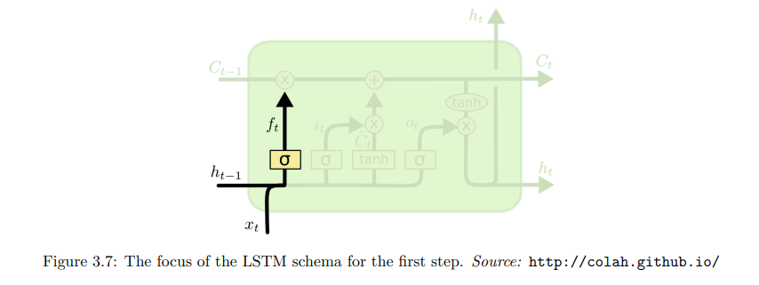

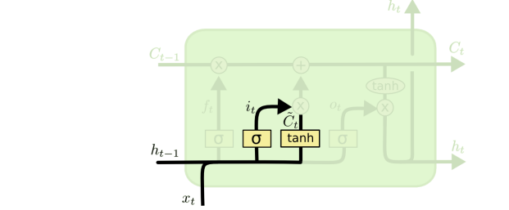

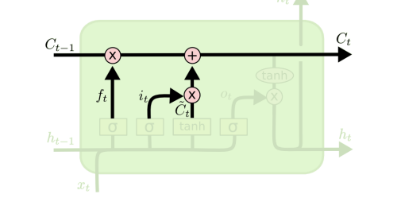

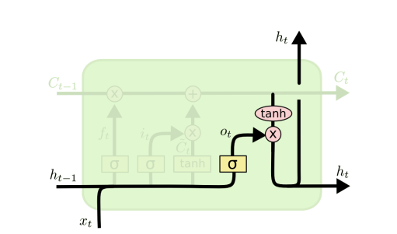

#### Low Level Diagram

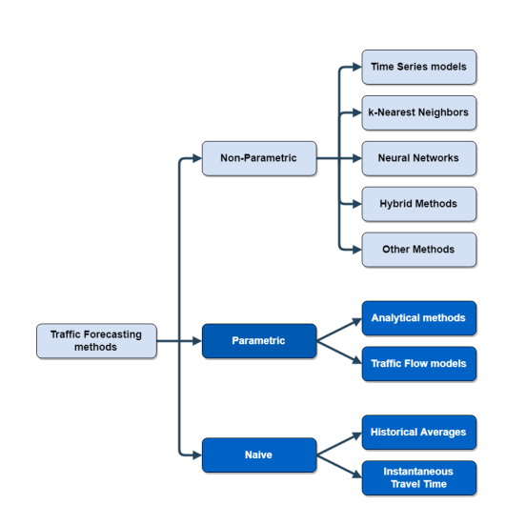

* 1. **Interfaces**

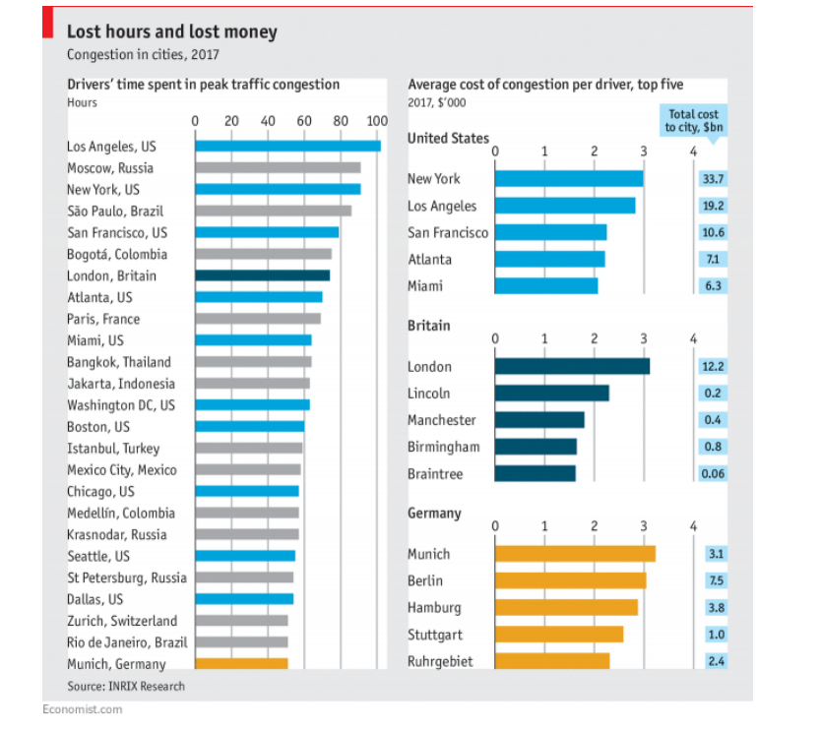

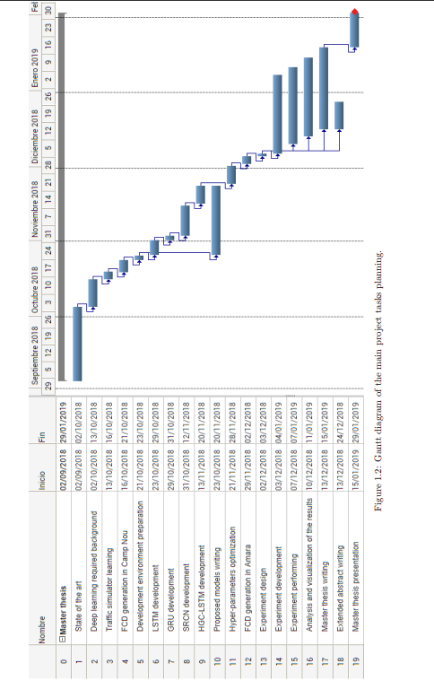

**6 Performance Test of an IoT-based smart distribution system:**

* To perform a performance test of the proposed project for forecasting smart city traffic patterns, you can consider the following steps:
* **Define Performance Metrics:** Determine the key performance metrics that you want to evaluate, such as prediction accuracy, forecasting time, system responsiveness, data processing speed, and scalability.
* **Test Data Preparation:** Prepare a representative dataset that includes historical traffic data, real-time data, and contextual factors. Ensure that the dataset covers a range of traffic scenarios, including peak hours, special events, and diverse weather conditions.
* **Test Environment Setup:** Set up the infrastructure and environment for conducting the performance test. This may include deploying the forecasting model on appropriate hardware, allocating sufficient computing resources, and configuring the necessary software components.
* **Performance Testing Scenarios:** Define different performance testing scenarios that cover a variety of traffic patterns and conditions. This can involve simulating various traffic scenarios, such as heavy congestion, sudden traffic disruptions, or unexpected events, and evaluating how the system performs under these conditions.
* **Execute Performance Tests:** Run the performance tests using the defined scenarios and datasets. Measure and record the performance metrics, including prediction accuracy, response time, throughput, and resource utilization.
* **Analyze Results:** Analyze the collected performance data and evaluate the system's performance against the defined metrics. Identify any bottlenecks, performance issues, or areas for improvement.
* **Scalability Testing:** Perform scalability tests to assess the system's ability to handle increasing data volumes and user loads. Evaluate how the system scales with larger datasets and concurrent users, ensuring that performance remains within acceptable levels.
* **Stress Testing:** Conduct stress testing by pushing the system beyond its normal operating capacity to identify its breaking point. Measure the system's performance, stability, and responsiveness under extreme traffic conditions.
* **Optimize and Refine:** Based on the performance test results, identify areas for optimization and refinement. This may involve fine-tuning the machine learning models, optimizing data processing algorithms, or improving system architecture and infrastructure.
* **Iterative Testing:** Perform iterative performance testing as you make enhancements or updates to the system. Continuously monitor and evaluate the system's performance to ensure it meets the desired performance criteria.

#### Test Plan/ Test Cases

* + Test Cases:
  + **Data Collection Test Cases: a.** Verify that data from sensors, cameras, GPS devices, and other sources is correctly collected and integrated into the system. b. Validate the accuracy and completeness of historical traffic data used for training the forecasting model. c. Ensure that real-time data is properly integrated into the system for up-to-date traffic pattern predictions.
  + **Model Accuracy Test Cases:** a. Test the accuracy of traffic predictions by comparing the forecasted traffic patterns with actual ground truth data. b. Validate the system's ability to predict different traffic scenarios, such as rush hour congestion, road closures, and traffic incidents.
  + **Real-time Data Integration Test Cases:** a. Verify that real-time data, such as sensor readings and live traffic updates, are correctly integrated into the forecasting model. b. Test the responsiveness of the system in updating traffic predictions based on real-time data.
  + **User Interface and Visualization Test Cases**: a. Validate the user interface for clear and intuitive visualization of traffic forecasts, including interactive maps, charts, and alerts. b. Verify that the system presents the forecasted traffic patterns in a user-friendly manner, enabling users to understand and interpret the information effectively.
  + **Performance Test Cases:** a. Test the performance of the forecasting model in terms of response time and processing speed for generating traffic predictions. b. Verify the system's scalability by increasing the volume of data and the number of concurrent users, ensuring that performance remains within acceptable levels.
  + **Contextual Factors Test Cases:** a. Validate the system's ability to incorporate contextual factors, such as weather conditions and special events, into traffic predictions accurately. b. Test the impact of contextual factors on the accuracy and reliability of traffic forecasts.

#### Test Procedure

* Test Procedure for the Smart City Traffic Pattern Forecasting Project:
* **Test Setup:** a. Set up the necessary hardware infrastructure, including servers, storage, and network components. b. Install and configure the software components, such as the forecasting model, data preprocessing tools, and visualization interfaces.
* **Test Environment Preparation:** a. Prepare a representative dataset that includes historical traffic data, real-time data, and contextual factors. b. Ensure the dataset covers a range of traffic scenarios, including peak hours, special events, and diverse weather conditions.
* **Test Case Execution:** a. Execute the defined test cases based on the test plan, covering various aspects of the forecasting system. b. Follow the specified steps and inputs to simulate different scenarios and validate the system's behavior.
* **Data Collection and Integration:** a. Verify that data from different sources, such as sensors, cameras, GPS devices, and mobile applications, is accurately collected and integrated into the system. b. Validate the integration of real-time data and ensure that it is being properly processed and incorporated into the forecasting model.
* **Model Accuracy Validation**: a. Compare the forecasted traffic patterns with actual ground truth data to assess the accuracy of the predictions. b. Validate the system's ability to accurately predict different traffic scenarios, such as rush hour congestion, road closures, and traffic incidents.
* **Real-time Data Integration:** a. Monitor and evaluate the system's responsiveness in updating traffic predictions based on real-time data. b. Verify that the system promptly incorporates new data and adjusts the forecasts accordingly.
* **User Interface and Visualization:** a. Validate the user interface and visualization tools for presenting traffic forecasts. b. Ensure that the interface provides clear and intuitive visualizations, interactive maps, and real-time alerts to users.
* **Performance Testing:** a. Measure and evaluate the system's performance in terms of response time, processing speed, and resource utilization. b. Conduct scalability testing by increasing the volume of data and the number of concurrent users to assess system performance under different loads.
* **Contextual Factors Validation:** a. Verify that the system accurately incorporates contextual factors, such as weather conditions and special events, into traffic predictions. b. Test the impact of contextual factors on the accuracy and reliability of the forecasts.
* **Test Result Analysis and Reporting:** a. Analyze the test results, including any issues or discrepancies encountered during testing. b. Document the test results, including observations, issues, and recommendations, in a test report.
* **Issue Resolution:** a. Address any identified issues and make necessary adjustments or enhancements to the system. b. Retest the modified components to ensure that the issues have been resolved.
* **Test Closure:** a. Review the test results, including the test report and any resolved issues. b. Obtain stakeholders' approval for the test completion and readiness for deployment.

### Test Execution:

Execute the test cases according to the test plan and record the actual results. Follow these steps:

1. **System Integration Testing:** Test the integration of system components, ensuring proper communication, data synchronization, and interoperability.
2. **Functional Testing:** Validate the system's key functionalities, such as data collection, real-time tracking, inventory management, and order processing. Execute tests for demand forecasting, analytics, reporting, and security features.
3. **Performance Testing:** Perform load testing and stress testing to assess system performance under different load conditions. Measure response times, throughput, and resource utilization. Evaluate network connectivity, bandwidth, and latency.
4. **Security Testing:** Conduct penetration testing to identify vulnerabilities. Verify authentication mechanisms, access controls, and data encryption. Test system resilience against attacks and data breaches.
5. **Usability Testing:** Conduct user testing to assess the system's intuitiveness, ease of use, and navigation. Gather feedback on user interfaces, dashboards, and mobile applications. Evaluate responsiveness and performance.
6. **Recovery and Failover Testing:** Simulate hardware or software failures to test system recovery mechanisms. Verify backup and restoration procedures. Assess failover mechanisms and the system's ability to restore normal operations.
7. **Compatibility Testing:** Test the system on different devices, platforms, and browsers. Verify compatibility with various operating systems and web browsers. Assess responsiveness and functionality across different screen sizes.
8. **Regression Testing:** Conduct regression testing after system updates or changes. Validate that existing functionalities remain unaffected and previously fixed issues do not reoccur.

**Record and Track Defects:** Document any defects encountered during testing. Include detailed information about the issue, steps to reproduce, and relevant test case information. Assign severity and priority levels to each defect.

**Retest and Verify Fixes:** After defects are fixed, retest the affected functionalities to ensure the issues have been resolved. Verify that fixes do not introduce new issues or impact other areas of the system.

**Test Reporting:** Prepare test reports summarizing the test activities, test results, and any open defects. Provide a clear overview of the system's overall quality, including areas of improvement, unresolved issues, and recommendations for further actions.

**Test Closure:** Evaluate the test phase against predefined exit criteria to determine if the system is ready for production deployment. Conduct a review meeting to discuss the overall test results, lessons learned, and potential improvements for future iterations or releases.

#### Performance Outcome

* + The performance outcome of the IoT-based smart distribution system project can be evaluated based on several key metrics and indicators. Here are some potential performance outcomes:
  + **Response Time:** Measure the system's response time for critical operations such as data collection, tracking, and inventory management. The goal is to ensure that the system responds promptly to user requests and provides real-time updates.
  + **Throughput:** Evaluate the system's throughput, which refers to the number of transactions or operations the system can handle within a given time period. The objective is to ensure that the system can handle the expected workload and meet the required performance targets.
  + **Scalability:** Assess the system's ability to scale up or down to accommodate increasing or decreasing loads. Measure how the system performance and resource utilization are affected as the number of IoT devices, data volume, or user activity increases.
  + **Reliability:** Evaluate the system's reliability by measuring its uptime and availability. The goal is to ensure that the system remains operational and accessible to users as expected, minimizing downtime and disruptions.
  + **Network Connectivity:** Assess the system's performance and stability under various network conditions, including low bandwidth, high latency, or intermittent connectivity. Measure the system's ability to maintain communication with IoT devices and handle network disruptions effectively.
  + **Data Processing Speed:** Evaluate the system's ability to process and analyze large volumes of data efficiently. Measure the speed at which data is collected, transmitted, and processed, ensuring that it meets the required performance criteria.
  + **Security and Data Protection:** Assess the system's security measures, including encryption, access controls, and data privacy. Verify that the system effectively protects sensitive data from unauthorized access, ensuring compliance with relevant regulations and standards.
  + **User Experience:** Gather user feedback and conduct usability testing to evaluate the system's user experience. Measure user satisfaction, ease of use, and the system's responsiveness to user interactions.
  + **Load Handling Capacity:** Measure the system's ability to handle high loads, including peak periods or sudden spikes in demand. Assess whether the system can maintain performance, responsiveness, and stability under heavy loads without significant degradation.
  + **Recovery and Failover:** Test the system's recovery and failover mechanisms to ensure its resilience and ability to recover from failures or network disruptions. Measure the time required to restore normal operations and assess data integrity during recovery.

### My learnings

* From the above project of forecasting smart city traffic patterns, there are several key learnings that can be derived:
* **Importance of Data:** The project highlights the critical role of data in accurate forecasting. Quality, comprehensive, and real-time data from various sources, including sensors and other data collection mechanisms, is essential for reliable predictions.
* **Integration of Contextual Factors:** Incorporating contextual factors, such as weather conditions, road construction, and special events, significantly improves the accuracy of traffic forecasts. Considering these dynamic factors enhances the system's ability to adapt to changing conditions and provide more precise predictions.
* **Machine Learning Algorithms:** The utilization of machine learning algorithms, such as neural networks and random forests, enables the system to learn from historical data and make predictions. These algorithms can handle complex patterns, adapt to evolving traffic conditions, and improve the overall accuracy of forecasts.
* **Real-time Updates:** The inclusion of real-time data integration enhances the system's responsiveness and ability to provide up-to-date traffic predictions. Integrating real-time sensor data, live traffic updates, and other sources ensures that the forecasts reflect the current traffic situation accurately.
* **User-Friendly Interface:** The importance of a user-friendly interface and visualization tools cannot be underestimated. Clear and intuitive visualizations, interactive maps, and real-time alerts enable users to understand and utilize the traffic forecasts effectively, empowering them to make informed decisions.
* **Performance and Scalability:** Performance testing and scalability assessments are crucial to ensure the system can handle increasing data volumes and user loads. Evaluating response time, processing speed, and resource utilization helps identify areas for optimization and ensures the system performs well under various traffic scenarios.
* **Collaboration and Decision-Making:** The project emphasizes the importance of collaboration among stakeholders, including city authorities, transportation agencies, and the public. Sharing data, open communication channels, and collaborative decision-making processes enable collective problem-solving and more effective traffic management strategies.
* **Continuous Improvement:** The project highlights the need for continuous improvement and adaptation. Ongoing monitoring, evaluation, and refinement of the forecasting system are necessary to address emerging challenges, incorporate new technologies, and adapt to evolving traffic patterns.

### Future work scope

* The future scope of the project on forecasting smart city traffic patterns is promising, with several potential areas for further development and enhancement:
* **Advanced Machine Learning Techniques:** The project can explore the utilization of more advanced machine learning techniques, such as deep learning and reinforcement learning. These techniques have the potential to improve the accuracy and robustness of traffic forecasts by capturing more complex patterns and dependencies within the data.
* **Integration of Emerging Technologies:** Integration of emerging technologies, such as Internet of Things (IoT), edge computing, and 5G networks, can enhance the real-time data collection and processing capabilities of the system. Leveraging these technologies can enable faster and more accurate traffic predictions.
* **Predictive Analytics and AI-driven Insights:** The project can further expand into predictive analytics and AI-driven insights for traffic management. By analyzing historical data, real-time inputs, and contextual factors, the system can provide actionable insights and recommendations for proactive traffic management strategies.
* **Multi-Modal Traffic Forecasting:** Expanding the forecasting capabilities to include multiple modes of transportation, such as public transit, cycling, and ride-sharing services, can provide a holistic view of urban mobility. By considering the interactions between different modes, the system can offer integrated route recommendations and optimize overall transportation efficiency.
* **Dynamic Routing and Adaptive Systems:** Integrating dynamic routing algorithms and adaptive systems can optimize traffic flow in real-time based on forecasted and current traffic patterns. By dynamically adjusting routes, traffic signal timings, and travel recommendations, the system can mitigate congestion and improve overall traffic management.
* **Integration with Smart Infrastructure:** Integrating the traffic forecasting system with other smart city infrastructure, such as smart traffic lights, smart parking systems, and autonomous vehicles, can enhance the overall effectiveness of traffic management. The system can interact with these intelligent infrastructure components to optimize traffic flow and improve mobility.
* **Predictive Maintenance and Infrastructure Planning:** Expanding the system's capabilities to include predictive maintenance and infrastructure planning can optimize road maintenance activities and support long-term infrastructure development plans. By analyzing traffic patterns and historical data, the system can identify areas prone to congestion or deteriorating conditions, enabling proactive maintenance and infrastructure upgrades.
* **Data-driven Policy Making:** The project can evolve to support data-driven policy making in urban transportation. By providing accurate traffic forecasts and insights, the system can assist city authorities and transportation agencies in making informed decisions related to transportation infrastructure, public transit services, and traffic management strategies.
* **Integration of Environmental Factors:** Integrating environmental factors, such as air quality data and emissions information, into the forecasting system can enable cities to consider the environmental impact of traffic patterns. This integration can support the development of eco-friendly transportation policies and promote sustainable urban mobility.
* **Seamless User Experience and Mobile Applications:** Developing user-friendly mobile applications and seamless integration with existing transportation apps can enhance the user experience. This includes providing real-time traffic updates, personalized route recommendations, and seamless integration with other mobility services.

**7. Conclusion**

In conclusion, the project on forecasting smart city traffic patterns has significant potential and offers valuable insights for efficient traffic management and urban mobility. Through the integration of data analytics, machine learning algorithms, and real-time data, the project aims to provide accurate and reliable predictions of traffic patterns in smart cities.

The project highlights the importance of data quality, including diverse data sources and real-time updates, in improving the accuracy of traffic forecasts. By considering contextual factors such as weather conditions, road construction, and special events, the system enhances its ability to adapt to changing traffic conditions and provide more precise predictions.

The use of machine learning algorithms enables the system to learn from historical data, identify patterns, and make predictions about future traffic patterns. The integration of advanced technologies and visualization tools creates user-friendly interfaces that empower users to understand and utilize the traffic forecasts effectively.

Furthermore, the project emphasizes collaboration among stakeholders, including city authorities, transportation agencies, and the public. By fostering open communication channels, sharing data, and enabling collaborative decision-making, the project promotes collective problem-solving and more effective traffic management strategies.

While the project has shown promising results and potential, it also acknowledges certain limitations and areas for improvement. These include data quality and reliability, scalability, dynamic factors, privacy and security concerns, and user-friendly interfaces. Addressing these challenges will be essential for the successful implementation and deployment of the forecasting system in real-world smart city environments.

In summary, the project on forecasting smart city traffic patterns contributes to the development of more efficient and sustainable urban transportation systems. By accurately predicting traffic patterns and enabling proactive traffic management strategies, the project aims to reduce congestion, enhance mobility, and improve the overall quality of life for residents and visitors in smart cities.

Continued research, technological advancements, and collaboration among stakeholders will further enhance the capabilities and impact of this project in shaping the future of urban mobility.